City Council STAFF REPORT
MEETING DATE: August 10, 2014

Title: First Reading of Bill _____ to amend Title 20 of the Sparks Municipal Code in its entirety and providing other matters properly relating thereto. Applicant: City of Sparks (CA-1-15)
Petitioner: City of Sparks
Presenter: Jim Rundle, Senior Planner
Recommendation: That the City Council instruct the City Clerk to read the First Reading of the Bill by title on August 10, 2014 and thereafter publish notice of a second reading and public hearing of this Bill for its possible adoption and possible approval on August 24, 2015.
Financial Impact: NA
Business Impact (Per NRS 237)
A Business Impact Statement is attached.
A Business Impact Statement is not required because this is not a rule.
A Business Impact Statement is not required. This is a rule but does not impose a direct and significant economic burden on a business, or directly restrict the formation, operation or exemption of a business.
A Business Impact Statement is not required. Thus is a rule but emergency action is necessary to protect the public health and safety (requires a unanimous vote of the City Council and cannot be in effect for more than six months).
Agenda Item Brief: In 2011 the City of Sparks elected to conduct a comprehensive overhaul of the chapter of its municipal code which governs zoning and development (Title 20). Title 20 regulates the use and improvement of land while controlling the location, soundness and use of structures located thereon. The City Council tasked staff with creating a document which removed “barriers to development,” created flexibility and provided predictability. This Code Amendment is the culmination of a three phased approach to create the revised Title 20 (zoning code) which will replace the existing zoning code in its entirety.

At the June 18, 2015 Sparks Planning Commission meeting, the board voted unanimously to forward a recommendation of approval to the Sparks City Council.

THIS IS THE FIRST READING.

Background:
In 2011 the City of Sparks elected to conduct a comprehensive overhaul of the chapter of its municipal code which governs zoning and development (Title 20). Title 20 regulates the use and improvement of land while controlling the location, soundness and use of structures located thereon.

In 2011, the City adopted a three phase approach. Phase I involved “quick fixes” to the code undertaken by City staff. Phase II was the analysis of the zoning code which ultimately produced a report identifying “barriers to development” and was completed with the help of Clarion and Associates and CFA of Reno. Phase III (which we are in now) is a comprehensive overhaul of the regulations affecting development.

In early 2012 the City awarded a contract for an analysis of the zoning code to identify barriers to development. The work was done by Clarion and Associates and CFA of Reno, and was completed in September 2012. The report (Zoning Code Assessment Report) identified barriers and provided the City direction for subsequent updates to the zoning code. Staff utilized this report to outline a work program for the next 18-24 months.

Phase III included a review of Title 20, the Phase II Zoning Code Assessment Report, the City’s draft comprehensive plan, Transit Oriented Development master plan and zoning standards and many other relevant plans, ordinances, and policies as identified by the City.

The objective of Phase III is to reformat the structure of Title 20 to improve its “user friendliness” and organization. To meet these objectives, the team needed to incorporate current best practices in zoning, facilitate appropriate uses and development, and consolidate multiple documents, regulations, and use and development standards into one document. This included the creation of a new master table of permitted uses, a redistribution of permitted uses across the zoning districts, and the limitation on certain uses or addition of new uses to districts.

Through an RFP process, the City Council in June of 2013 selected White and Smith, in conjunction with Winters and Company and CFA of Reno, to support the City (from here on referred to as “the team”) in developing the reformatted Title 20.

Tasked with consolidating multiple documents, clarifying opportunities, providing more flexibility, and reducing discretionary review to improve predictability, the team initiated the process immediately and began addressing the permitted uses in the City’s zoning districts, the foundation of any zoning code.
The team’s first step in the creation of the new Title 20 was to reconstruct the format by grouping permitted uses into a single table. Development of this table is the foundation of the reorganization and formatting of the Zoning Code. Completion of the draft permitted use table provided for the first opportunity to share and discuss the draft with the stakeholders that had provided input in the Phase II process. Stakeholders could see how the new format would provide for clarity and predictability. In May of 2014, over two days, the team met with approximately 35 stakeholders from a variety of disciplines in the area, including but not limited to planning, real estate, development, engineering, brokerage, economic development and construction. These meetings provided invaluable discussion with the professionals who would ultimately be using the code. The team was able to consider all of the input and discussion on the draft permitted use table and confidently move forward with the development of the rest of the zoning code draft.

Over the course of the next 10 months the team worked to consolidate documents, clarify standards, develop flexibility and reduce discretionary review by instituting use standards, thereby creating predictability and ultimately creating a draft that combine five documents into one, and reduced the former Title 20 from 103 chapters to nine chapters.

Completion of the draft provided an opportunity to go back to the stakeholders (March of 2015) and begin reviewing, discussing and editing the document. The team then presented the draft to the Planning Commission in a workshop format. Certain highlighted items were discussed and the Planning Commission direction for further modifications to the draft code. A City Council workshop occurred in April 2015 with a similar presentation. At the City Council workshop, the team was able to discuss the stakeholders and Planning Commissions’ input on the draft.

Paralleling this workshop process were two meetings with stakeholders interested in the Urban Agriculture component which has been proposed as part of the draft. The proposal allows for Urban Agriculture as a primary use and allows chickens and bees as accessories to established residential uses. The second meeting, which was noticed through Sparks’ media outlets, and held at the Sparks Police Department, was a success in that all those attending were able to reach a common consensus on how they would like to see the draft go forward through the public hearing process.

As noted earlier, the draft code incorporates the design standards manual into the Title 20. The team invited local architects to form a small working group to create design standards that provided architects flexibility in design while setting standards for developing in Sparks. The team met with the architects four times. The proposed draft now includes the building design standards in the same section as other development standards such as building setbacks.

After numerous workshops, stakeholder meetings, and team meetings, the final draft was completed in late May of 2015. The team once again went to the stakeholders and discussed how earlier comments were incorporated, or explained why some comments were considered but not reflected in the current draft.

The culmination of these processes is the proposed new Title 20. Changes to the zoning code must be adopted by an ordinance which requires two readings by the City Council. The proposal was forwarded with a unanimous recommendation of approval to the City Council by the Sparks Planning Commission at its June 18, 2015 meeting.

At this meeting there were revisions made which were incorporated into the Planning Commission’s motion for approval. These items have been incorporated into this City Council draft. These revisions proposed and adopted included:
-A graphic depicting building envelope
-Modification to allow more temporary uses
-Permit freight containers in the Industrial zoning district.
-Prohibited Practices; Non Domestic Animals (Feral cats).

Analysis:
There have been many amendments to the Sparks Zoning Code since its inception in 1976. Numerous chapters have been amended, and chapters have been added over the last 38 years. To date, the original format had been maintained. A substantial portion of the zoning code, particularly the new amendments, is retained in the new code but in a manner that should be easier for people to use without contacting a planner. For example, the current Title 20 provides regulations regarding “Electric Fences” in a chapter titled “Height Limits.” The proposed code provides for regulations regarding “Electric Fences” in a chapter titled, “Development Standards – Fences.”

The “Background” section touched on the goals for the development of the new zoning code, but more specifically, the City Council’s direction to staff was to develop regulations that encourage smart growth with design-based zoning that allows flexibility but is also predictable. With this in mind, the team also was intent on not overstepping the mandate from the City Council. The team wanted to create a zoning code that incorporates best practices, takes into account local practice, is easy to understand, and creates a business-friendly environment in Sparks.

Creation of such a document is challenging. Coordination with the local stakeholders identified that incorporating graphics into the code would help. This draft includes illustrations, pictures, tables, charts, lists, and other similar graphic depictions to support the text and provide clearer representations of the policy.

The foundation of the draft code, as discussed earlier, is the permitted use table. The existing Zoning Code is cumbersome because the permitted uses are listed in individual chapter for each zoning district. This makes it difficult for example, for someone to determine the zoning districts in which a particular use is permitted without consulting numerous chapter of the code, as follows:

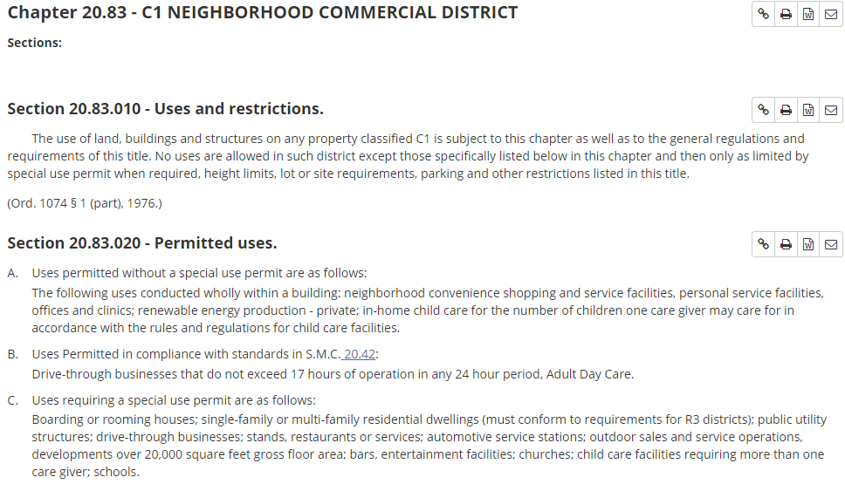

In the proposed code, you identify the use you desire to conduct and then review a table in a row and column format to quickly identify where the use is permitted.
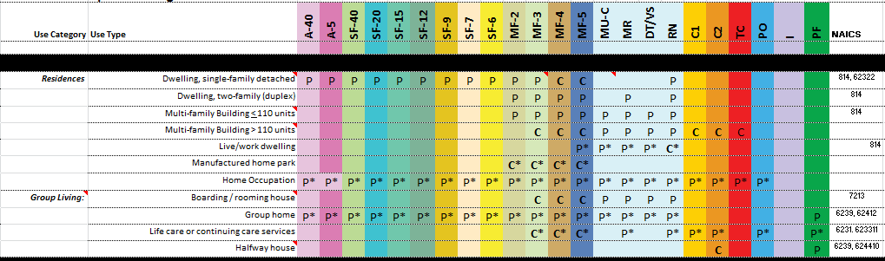

This use table also utilizes the North American Industry Classification System (NAICS); which is the standard used by Federal agencies to classify business according to type of economic activity and is also commonly used by the real estate/brokerage community. Business License division utilizes the NAICS system as well. Including this column in the permitted use table promotes consistency between the Planning division and the business license divisions. More importantly, it provides flexibility when classifying a use because the NAICS would allow a planner to determine whether a use that is not explicitly permitted in the code is similar to uses that are included. By incorporating NAICS codes in the use table, the use table can evolve as NAICS evolves.

This proposal includes approximately 125 uses whereas the existing code included over 170. Utilization of the NAICS provided the foundation for the team to remove confusing terminology and/or obsolete uses from the existing Title 20, while still adding 45 additional uses.

This application of clear and concise terms regarding permitted uses was applied to the various chapters of Title 20. There are currently 103 chapters in the Title 20; there are six chapters in the Design Standards manual; and, there are three manuals governing development for the Transit Oriented Development corridor. All of the preceding chapters/manuals have now been consolidated into one Title 20 with nine chapters.

This staff report goes on to identify proposed amendments which will reduce “Barriers to Development in Sparks,” as was directed by the City Council. During all phases of the development of this Zoning Code, the City Council consistently directed staff to reconsider policies regarding Transit Oriented Development (TOD). While restricted by certain policies in the Truckee Meadows Regional Plan, the team has not only proposed changing standards but proposes changing the name of the district.

Transit Oriented Development can be found in metropolitan areas across the world. Successful TOD requires substantial investment in the transit system, typically by way of light rail. It is unlikely the City of Sparks or RTC will be able to provide the investment required to provide for TOD along Prater or Victorian Avenue that leads to the high density and intensity found in Chicago, New York, or San Francisco. That is not to say, however, that these corridors cannot evolve to focus centered on walkability and multi-modal transportation. The team has proposed renaming the Transit Oriented Development corridor to the Mixed-Use district (MUD). The mixed-use corridor standards are proposed to create compact urban form; appropriate to developed along Prater Way and Victorian Avenue including higher-density residential which permits vertical and/or horizontal mixing of uses. The proposed regulations promote a mix of uses with an efficient and compact development pattern that encourages shared parking and economical use of land. The team has proposed adding uses back to the MUD district such as drive-thru restaurants and light vehicle repair which had been removed in the creation of the TOD. The removal of those uses tied the hands of the City when trying to permit certain business along Prater Way and Oddie Boulevard. The MUD proposal continues to include minimum density and intensity standards. The standards are required to conform to the Truckee Meadows Regional Plan. Any further reduction in the intensity or density standards would require Regional Plan amendments.

Because the Regional Plan does not govern design, staff has proposed “tweaks” to the MUD design standards for sidewalk width. Currently, the TOD manuals require sidewalks to be 12 feet in width along Prater Way and Victorian Avenue. All other sidewalks within the TOD corridor are required to be six feet in width. The team is proposing to modify these standards and require all sidewalks to be four feet in width except for sidewalks within Victorian Square, which would be specified through the development review process. These changes to sidewalk standards are proposed to reduce the costs of developing in the TOD/MUD.

The team’s proposal also includes a change in the requirements to have more than one use on a property. Currently, when developing on a site over an acre in size, a developer is required to provide two types of uses, when over five acres the requirement is to provide three types of uses. This requirement has been struck. There is no minimum number of uses required on a site; it is simply up to market conditions to dictate the variety of uses on a site.

The team continued this perspective into creation of the Single Family Residential design standards. Beginning in the 1990’s and continuing to the present, the utilization of Planned Developments became prominent for all new large scale development in the City of Sparks. The reliance on the Planned Development process can be attributed to what had already become an antiquated zoning code (1976) that lacked flexibility in design. The Planned Development process was a way to respond to market demands for new product types and the Planned Development process was utilized for the next 20 years. This zoning code update is intended to provide flexibility in design of single family residential and thus encourage developers to utilize the City’s standard zoning rather than Planned Developments. The site planning standards in the proposal allow for small/cluster lots and varying setbacks. The team is proposing standards where overall density will remain the same as former zoning would permit, but can potentially allow for smaller parcel size and significantly reduced setback requirements. The example below illustrates this flexibility as applied in the SF6 zoning district. Conventional development in this district requires a 15 foot front setback and 20 foot rear setback for a total of 35 feet. This option provides an example permitting any combination of front and rear setbacks as long as the total setbacks equal 35 feet.
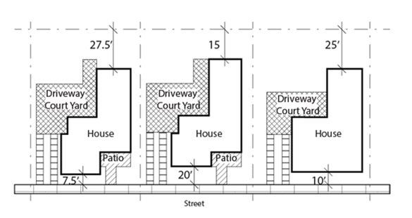

The proposed code also includes a standard in the Single Family Residential chapter that states, “Exterior color elevations for all sides with proposed materials shall be provided for review and consideration by the Administrator prior to the issuance of a building permit.” Such a standard does not require a developer to determine building design prior to creation of the subdivision. This also provides flexibility for the developer to work out design issues with staff as opposed to being bound by a design standard imposed at the City Council public hearing. When design occurs at a public hearing it often times requires a developer to go back to the Planning Commission for any modifications required at a later date, adding significant time and expense to the developer. Such expense may be better spent on enhancements to the architecture and site landscaping.

Landscaping a site reduces air pollution by the use of vegetation, which absorbs carbon dioxide and produces oxygen, reduces noise, dust and erosion, buffers structures from noise and enhances the aesthetics of a community. To promote the maintenance and enhancement of sites, the team has proposed simply landscaping the frontages of buildings in the Industrial area. The current code requires six percent of the site to be landscaped. This requirement does not necessarily promote better design. Also, landlords or businesses may install landscaping as required but then neglect it which neither promotes the City or the site. The following illustration depicts the proposed change to the landscaping requirement for the I (Industrial) zoning district.

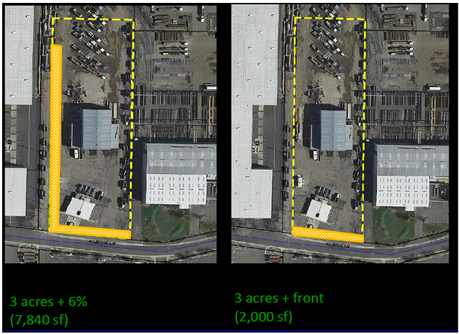

Landscaping to meet a regulation currently requires this site to landscape along the western property line, which the business may consider to be of little value. The western property line faces a building. With the large size of many of Sparks’ industrial properties, the requirement to landscape the frontages should provide for landscaping that a property owner desires to maintain as it enhances their site and provides “curb appeal.”

The landscaping standards for most of the City’s other zoning districts still require a minimum percentage of the site to be landscaped. The team also cross checked the proposed percentages and found the City’s requirements to be the same or similar as other municipalities’ requirements. In order to promote the restoration or enhancement of buildings in the City, the team has proposed adding landscaping flexibility when expanding an existing building: “An expansion to any existing building, when not in conformance with the minimum landscaping requirements shall provide a proportionate amount to the expansion.” For example, a 10,000 square foot existing building, with a 1,000 square foot expansion (or 10%) in the C2 zoning district (requires 15%) would only require 1.5% of the site to be additionally landscaped (.10x.15=.015).

Additionally, reflecting direction by the City Council at the zoning code workshop, the team has proposed reducing tree requirements along the frontages across the board from one tree every 25 feet to one tree every 30 feet. This proposed amendment should allow more room for trees to mature and reduce the necessity to remove trees. This proposal will also reduce the concealment of site facilities that warrant visibility including but not limited to building and signage. A goal of this change is to provide for a more aesthetically pleasing building while still providing for a tree canopy that creates a desirable place to walk due to the reduction in heat and a buffer from the speed of the street.

Flexibility in parking standards is also a common request. The team has proposed to permit parking reductions when and where appropriate through a parking analysis/study. In the case which an applicant cannot comply with the standards set forth in the parking ordinance, the draft provides for a variety of mechanisms to potentially reduce the parking requirement to reflect the site’s neeeds. These mechanisms include the use of the minor deviation tool, joint use parking, shared parking, alternative requirements, off-site parking, and even on-street parking in the Mixed Use District. These mechanisms are proposed to be approved based on analytical parking studies. These deviations to the parking requirement are, again, proposed to be administratively permitted as opposed to consideration through the public hearing process.

As directed by the City Council, the team has generally proposed standards to give staff more discretion while not providing staff the opportunity to set policy. This is most apparent in the reduction of the requirements for discretionary permits and instead permitting uses by right with use standards. There are a number of uses in the municipal code which require discretionary approval in the form of a Special Use Permit. As a Special Use Permit requires individual noticing to neighborhoods within proximity to the project, staff has noticed that many citizens misunderstand the purpose of a Special Use Permit. The term “special use” suggests an applicant desires some sort of use variance, whereas the discretionary permit is to identify and mitigate through the imposition of conditions, potential impacts to the neighborhood through the public hearing process. In response to this misconception, the team is proposing to change the name of the Special Use Permit to Conditional Use Permit. Conditional Use Permit is actually the term utilized in the Nevada Revised Statutes (NRS) and more accurately indicates its purpose is to allow permitted uses with discretionary conditions that provide for consistency and compatibility with the neighborhood where it is located. The permitted use table identifies which uses require a Conditional Use Permit with a “C.” Generally, uses not listed in the use table, are presumed to be prohibited. Uses that are not in the use table, that are similar to uses that are, based on NAICS, could be permitted if they are found to be materially similar to other uses permitted in the respective zoning district. While it is impossible to contemplate every possible use or new uses that did not exist when this section was written the team has proposed a mechanism to ensure that uses not listed in the table have a path to potential approval. These cases will be considered by the Planning Commission through the Conditional Use Permit process. This process is approximately 45 days, whereas the current process is:
- Request made by applicant to elected official to initiate a code amendment.
- Request to consider a code amendment presented at a Council meeting by elected official.
- Code amendment is considered at a second public meeting by the entire City Council directing staff to initiate the code amendment.
- Staff recommends code amendment to the Planning Commission.
- Planning Commission recommends code amendment to City Council
- City Council reads the code amendment into the record during a first reading.
- City Council considers the code amendment at a subsequent meeting for final approval.
This process can take six months to provide for the required public hearings. The proposed mechanism could take as little as 45 days, which reduces another barrier to development in Sparks.
Applicants whose Conditional Use Permits are approved have two years to establish the use. Applicants who are not able to establish their use within two years may request an additional year from the Planning Commission prior to the approval expiring. The current municipal code is silent on when a Conditional Use Permit, once established, expires if it ceases. For example, a gas station receives a Conditional Use Permit, establishes operation and operates within the confines of the permit for ten years. The operator then closes the gas station, and it sits idle for the next year and the business license expires. The team is proposing a standard that identifies an issued Conditional Use Permit does not expire for one year after the business license for the use expires. This will provide the opportunity for another operator to utilize the existing approvals for a use and simply began operation whereas currently the operator would need a new Conditional Use Permit to allow for a use that was previously approved.
Along the same lines, the team is proposing to extend the expiration dates for nonconforming uses as directed at an initial City Council workshop. Nonconforming uses (a use that is no longer permitted in a zoning district) currently need to be reestablished within six months of the use ceasing operation or the use is considered abandoned and cannot be reestablished at that site. Through deliberation at the City Council workshops direction was given to extend this period. Based on the view that six months was simply not enough time for a broker/property owner to identify a new user and obtain a business license to continue the nonconforming use. The team has proposed extending the nonconforming use expiration date from six months to two years. The stakeholders group advised that two years is ample time to continue a nonconforming use; any time beyond two years and the use is likely no longer viable .
The Planning Commission is acting in an advisory authority to the Sparks City Council when it votes on this ordinance. The ordinance will then be scheduled for a first reading and then a public hearing before the Sparks City Council. Upon approval by the City Council of the ordinance, the proposal will become effective and replace the TOD design manuals, Design Standards manual, and the existing Title 20.
The process of amending this code has been a concerted effort involving elected officials, appointed officials, local stakeholders, public and private planners and City staff from varying disciplines. This proposal, once adopted, will conclude a three phase approach to identifying barriers to development in Sparks and through a code that promotes excellent design and predictability while maintaining flexibility through more administrative discretion.

Alternatives:
First Reading Only

Motion:
First Reading Only

